Nicholas Deniz
CS-499 Capstone Grazioso Salvare Algorithm and Data Structure Enhancement Narrative
Professor Satish Penmatsa
9/25/2026
Grazioso Salvare Description:
The artifact I chose for my second enhancement is the Grazioso Salvare animal rescue dashboard. I originally worked on it in CS 340 Client Server Development. I enhanced the application for CS 499 in September 2026. The dashboard uses Python, Dash, pandas, Plotly, Dash Leaflet, and MongoDB to retrieve and display animal shelter records. Users can filter animal records by different rescue categories like water rescue, mountain or wilderness rescue, and disaster or individual tracking. The application displays those results in a table, a breed chart, and a map.
Reason for Choice:
I chose this artifact because it combines a database, data processing, and an interface in an application. The original dashboard could retrieve and filter animal records, but it did not have or show an algorithm for organizing those results. Adding a sorting algorithm improved the dashboard while showing my understanding of algorithms, data structures, performance, and the ability to change and improve the existing application.
Enhancement and Skills Demonstrated:
For the enhancement I created a separate file called animal_merge_sort.py and implemented a merge sort. The algorithm processes a list of dictionaries representing animal records. Accepting a sorting field and a choice to view it in descending or ascending order. Users can sort the records by age, name, or breed.
The implementation handles numbers and text values differently. Age values are compared numerically, while names and breeds are compared without paying attention toward capitalization. Missing or incorrect values are placed at the end of the result no matter the sorting direction. When two records have equal sorting values the original order is kept. The function also returns a sorted copy instead of changing the input list to help control issues that could crop up.
I added the algorithm into the dashboard using a dropdown for choosing the sorting field and buttons for choosing the sorting direction. The dashboard callback retrieves records that match the active rescue filter, removes the MongoDB ObjectId field, and passes the rest of the records into the merge sort function. The sorted records are returned to the table. When results are available the dashboard would return to the first page and select the first record.
Keeping the selected rescue category was important. Changing the sorting field should continue to show animal records from the category a user would choose. I used a Dash store to keep that category even when a callback updates. This let the filtering and sorting options working together without having the user reselect what they had already picked.
Algorithm Selection and Design Reasons:
I chose the merge sort because it gives a O(n log n) ren time which scales more effectively than O(n^2) from bubble sort. Merge sort divides the input into smaller lists, sorts the smallest objects, and then merges them. The main tradeoff would be extra memory is needed during the merging. It uses O(n) temporary auxiliary memory with a O(log n) recursion stack. This tradeoff is still good as it is a consistent performance even if the number of records increases. Using a list of dictionaries also let the algorithm work directly with the animal records retrieved from MongoDB. Each dictionary keeps an animal’s fields together while the list figures out the order the records will appear in.
I chode to write a merge sort so I could show that I understood that an algorithm splits records into smaller elements and merges them in order. Python already has a built-in sorting function called sorted(). It is efficient, keeps equal values in the original order, and returns to a new list. Also, it keeps the dashboards rules with missing or invalid values. I would choose the built-in function because it would be easier to maintain and use. However, writing the merge sort was useful for the enhancement as it showed off and tested my knowledge and skill of the algorithm. My performance comparison showed that merge sort was more useful in this case than bubble sort but it didn’t show that it was better than Python’s sorting.
Merge sorts keep records with equal sorting value in the original order. The left_first() function uses <= for ascending and >= for descending. Both comparisons choose the record from the left list when the values are equal. The function checks for missing and invalid values before doing the sorting direction. Keeping the records at the end in both orders. When both values are invalid the left record is chosen so the original order is kept.
Testing and Performance:
To test and compare the enhancement I create compare_sorts.py. This file generates repeatable animal records using a consistent random seed. It would compare the merge sort with a bubble sort. Before measuring the performances, I would check that both algorithms have the same ordered records. It would then measure each algorithm five times and display the median time.
Performance Results:
Number of records | Merge sort | Bubble sort
200 | 0.598 milliseconds | 1.483 milliseconds
800 | 3.012 milliseconds | 26.880 milliseconds
1,500 | 6.032 milliseconds | 99.534 milliseconds
These results support the difference in how the algorithms scale. As the number of records increased the bubble sort needed a lot more time than the merge sort. This also showed that the Python files were successful and that the comparison assertion passed. It also proved that the ascending order and valid records were correct. These checks helped show that the algorithm can handle these kinds of records in the dashboard.
Testing Merge Sort:
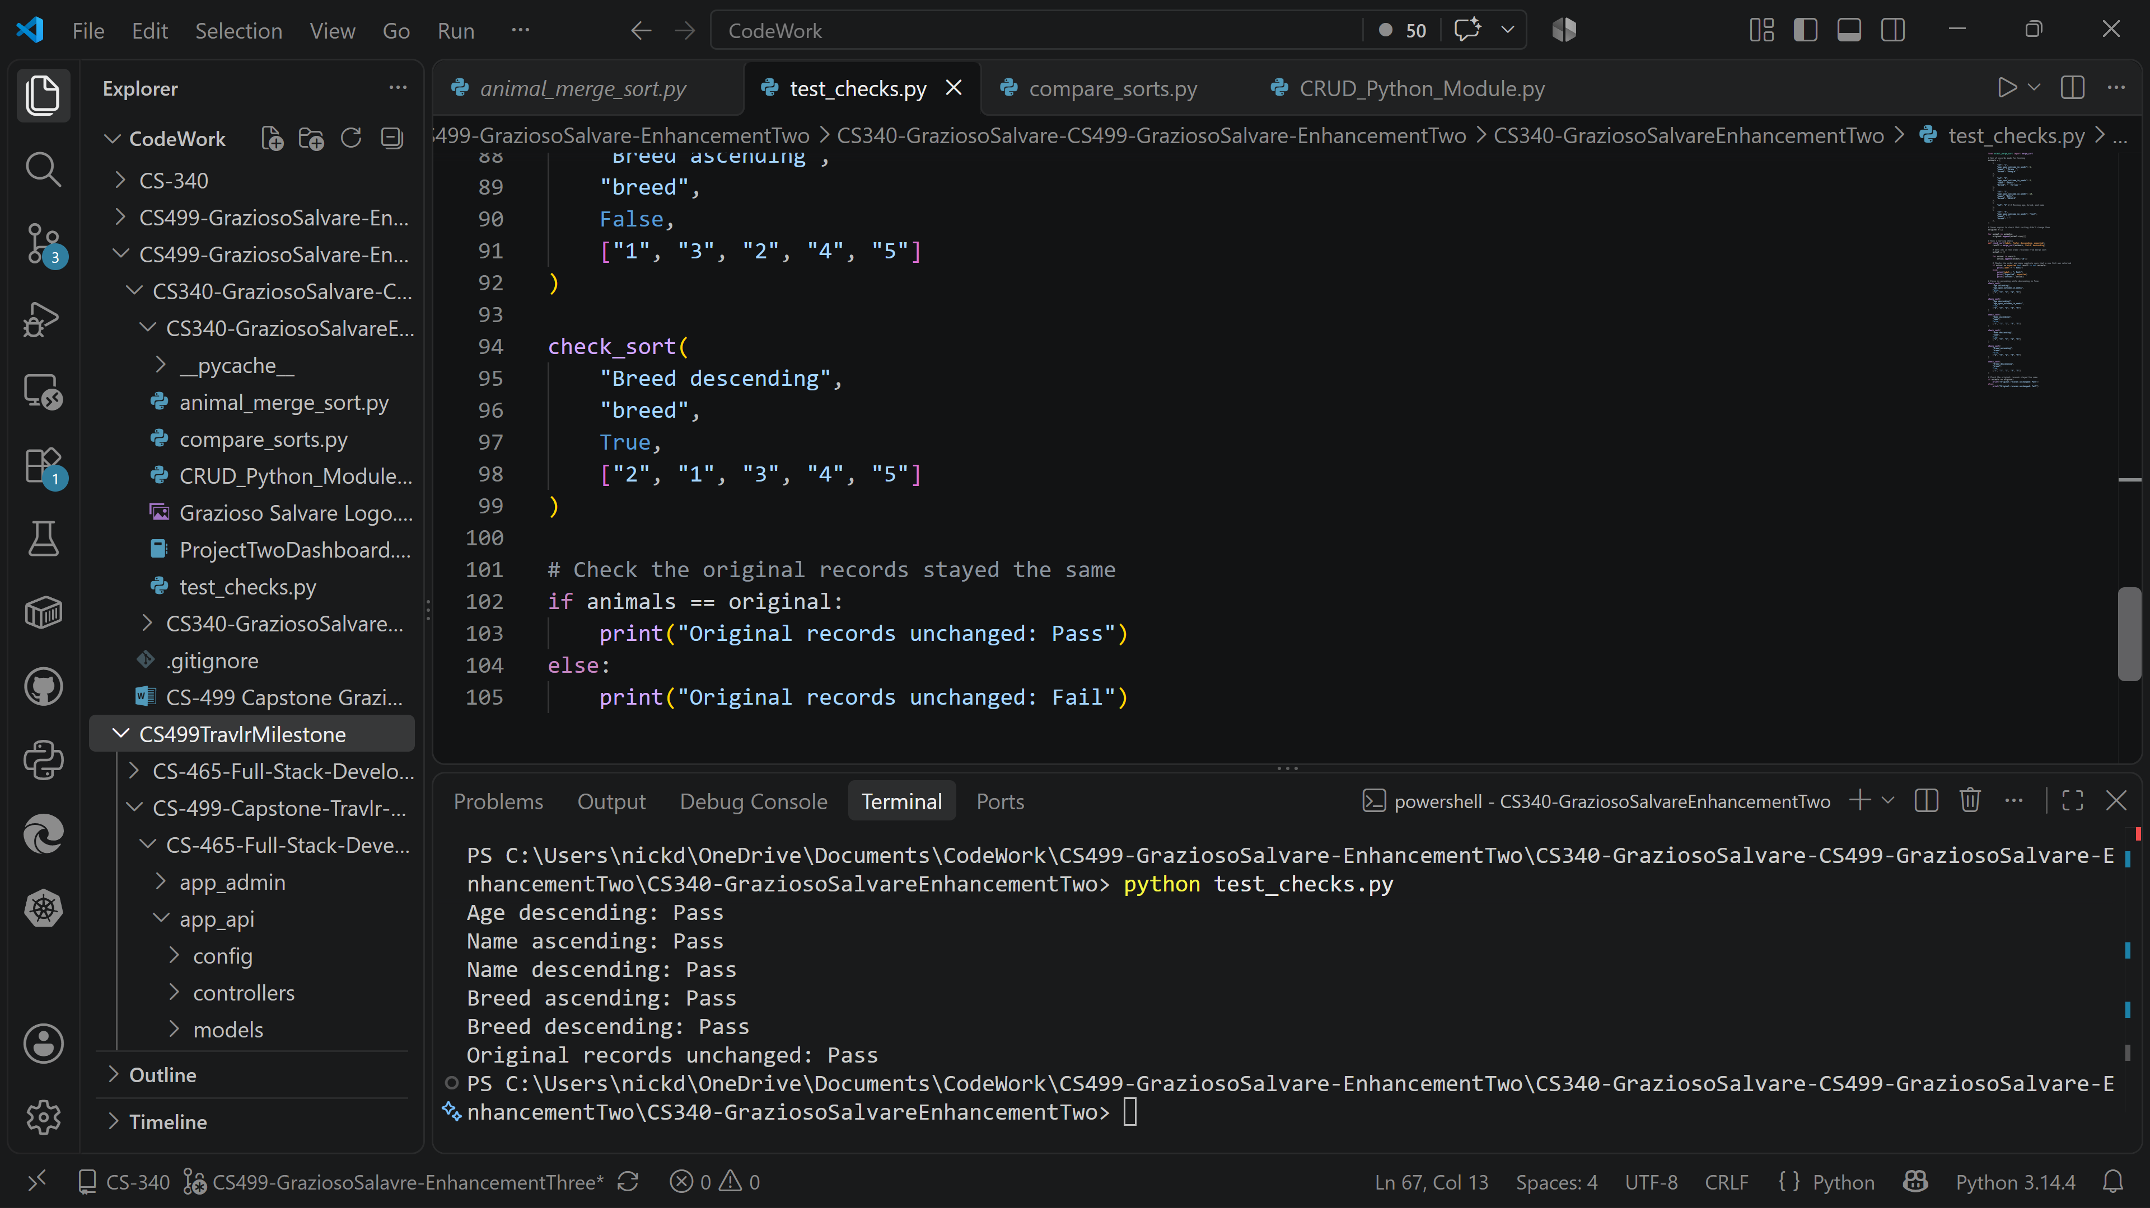
I added a file called test_checks.py to check the sorting rules. I tested age, name, and breed in ascending and descending order. The records had equal values, missing info, incorrect age, empty text, and lowercase, capitals, and whitespace. I compared each result with the expected order. All six sorting checks passed. Records with equal values stayed in the original order and records with missing or invalid values went last. The checks also showed the the function returned a new list and didn’t change original records.
Course Outcomes:
This enhancement fulfils the algorithms and data structure’s goal of implementing and evaluating an algorithm with an existing application. It shows the CS program outcome with design and evaluating computing solutions using algorithmic principles while keeping tradeoffs in mind. I dealt with the specific ordering problem, picked an appropriate algorithm, considered their time and memory needs, and evaluated its behavior by testing and performance comparisons.
I implemented a reusable merge sort algorithm in the Grazioso Salvare dashboard to organize animal records by age, name, or breed in ascending or descending order. For example, if the user picks the Water Rescue filter and sorts animals with ages like 56, 78, or 46 weeks in ascending order then the dashboard would display them as 46, 56, and 78 weeks while keeping the selected rescue category. This connects the algorithm to a needed task by helping users evaluate eligible animals in their wanted order. I also compared merge sort with bubble sort using the same artificial datasets and continuously increased them to evaluate their performances. Merge Sort’s O(n log n) time complexity gives better scaling than bubble sort O(n^2). However, it needs O(n) additional storage for temporary lists. Going into detail about this tradeoff offers supporting evidence of my algorithm of choice and its computational costs.
This enhancement also supports the outcome involving the computing solutions and the tools that were needed to create those solutions. I connected a reusable Python file with MongoDB query results, Dash callbacks, stored interface state, and interactivity of the dashboard. The interface labels and explanation of the design give evidence for professional communication. What I mainly covered remains with algorithm design and evaluation as it is the strongest piece of evidence.
Challenges and how they were Overcame:
One of the main challenges was making the algorithm reliable with different kinds of animal data. Implementing recursive division and merging wasn’t most of the work. Age values needed to be sorted as numbers, names and breeds needed text normalization, and missing or incorrect values needed to be handled, especially when the user picks descending order. I handled these cases in a single part of the code so the merge sort could follow the same rules whenever it’s used.
Another challenge was checking the performance comparison’s reliability. The time needed to run a program could change a bit each run affecting the results. I used the same sample of records each time for both sorts, checked that the records were put in the same order and ran each test five times. I reported the median and tested increases in data sizes. Giving me a clear picture of how each algorithm performs as the records increased.
Another challenge was altering the existing original application, so the new sorting controls worked with the original rescue filters. The dashboard had already updated the table when a user chooses a rescue category but changing the sort field could cause that category to be lost. I modified the callback to handle filtering and sorting and added a Dash store to keep the previously selected category. I also fixed the callback to use ctx.triggered_id after an invalid reference that caused the filter to stop responding. When new code is added it affects the original application in new ways.
Reflection:
Throughout this enhancement I increased my understanding of algorithm design and how it affects an existing application. Picking an algorithm needs more than just checking the Big O complexity. I reliable implementation needs to foresee equal values, missing or invalid records, incorrect inputs, changes to shared data, and the interactive interface.
Separating the algorithm from the dashboard made it easier to test the concerns and implement the validated behavior. I learned how to use performance measurements to provide evidence of a design decision while understanding their limits. This enhancement helped my ability to put together algorithmic concepts and explain their tradeoffs.

